PRODUCT DETAILS

**Hugo Boss Watch 1502553**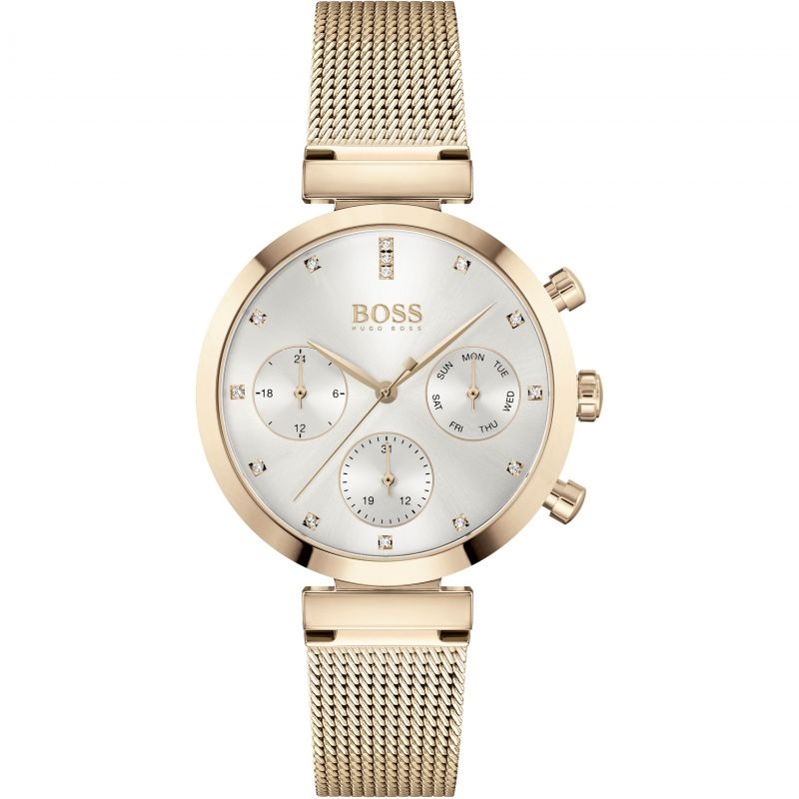

**£239.00**

**Specifications**

**Brand**: Hugo Boss

**Analogue/Digital**: Analogue

**Case** **depth** **approx**.: 9.15mm

**Primary** **Material**: Plated Stainless Steel

**Case** **Shape**: Circle

**Case** **width** **approx**.: 36.00mm

**Clasp** **type**: Fold-over Deployment

**Dial** **Colour**: Silver

**Multiple** **Time** **Zones** **Display**: Dual Time

**Gender**: Ladies

**Glass**: Mineral

**Hour** **Markers**: Stone Markers

**Model** **Collection**: Flawless

**Model** **Name**: Flawless

**Movement** **Source**: Swiss

**Movement**: Quartz Multifunction

**Strap** **colour**: Gold

**Strap** **Type**: Metal bracelet

**Water** **Resistance**: 30 metres

**Weight (g):** 56.00

**BARCODE**: 7613272416177

**Guarantee**: 2 years